## **Organization Hierarchy Distribution Analysis**

There is a company “XYZ”. Given an organizational hierarchy consisting of a boss and multiple employees. There are number of tasks Listed below. The main goal of these task is to obtain a comprehensive understanding of the organizational structure, the number of levels in the hierarchy, the salary distribution, the relationships between the employees, the size of each employee group, and the first or just boss of each employee, which can assist in various decision-making processes such as budget allocation, performance evaluation, and employee satisfaction.

• Find the nearest common boss for a pair of employees.

• Determine the total number of employees in the organization.

• Find the just boss of a certain employee.• Determine the number of employees working under a certain boss.• Identify the number of levels in the organizational hierarchy.

• Analyze the different salary levels for the employees in each level.

|  |  |  |  |
| --- | --- | --- | --- |
| **Function** | **Arguments** | **Return type** | **Function Description** |
| Datatiding | Vector<vector<int>> | void | This function takes an input edges of tree and performs preprocessing to enable O(1) lookup of certain functions. |
| dfs | Int | int | This function is call when  Datatiding is called. |
| Commonboss | int  Employee1  Employee2 | int | It has two int parameters giving the Employee1 and Employee2. The function helps Finding the nearest common boss for a pair of employees |
| Justboss | Int | int | This function take input as employee and return an output  as just boss of employee. |
| Numofempunder | int | int | This function takes the any certain employee of organization as an input and returns the number of employees working under him. |
| level | void | int | This function does not take any argument as an input but it returns number of levels. |
| levelsalary | int | int | This function takes level as an input and returns the salary respected to that level. |

Constraint:

The Hirerical level must not be greator than 10. The 0 level salary is 100000 and the when level value increase than each level 8000 reduce from privious level salary.

**TestCases:**

**Sample Test Case**

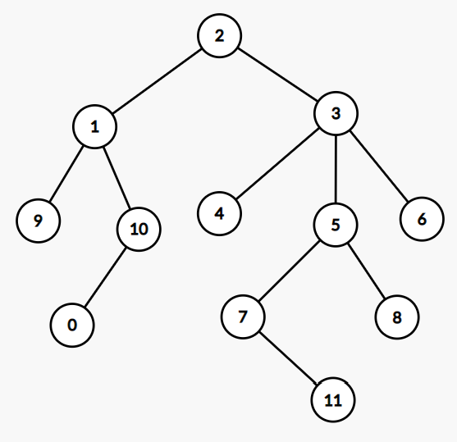

|  |  |  |  |  |
| --- | --- | --- | --- | --- |
| **Test Case** | **Test Case Description** | **Input** | **Expected Output** | **Explanation** |
| testZero | levels | void | 4 | After preprocessing the value we get |
| testOne | Level salary | level value=2 | 84000 | The 0th level salary is 100000 and in second level it reduce by 16000 |
| testTwo | Number of employee working under some employee | Node value=1 | 3 | Node 1 has three employee working under him |
| testThree | Just boss of some client | Node value=5 | 3 | The just boss od node 5 is 3 |
| testFour | Common boss of two employee | Node value1=1  Node value2=4 | 2 | The common boss of node 1 and 4 is 2,  who is ultimate boss |
| testFive | Level salary | Level value=5 | -1 | The 0th level salary is 100000 and there is only 4 level in given sample and level value 5 so it will return -1. |
| testSix | Common boss of two employee | Node value1=5  Node value2=4 | 3 | The common boss of node 5 and node 4 is 3. |
| testSeven | Number of employee working under some employee | Node value=2 | 11 | Node 3 has eleven employee working under him |
| testEight | Just boss of some client | Node value=0 | 10 | The just boss od node 5 is 1. |
| testNine | Number of employee working under some employee | Node value=5 | 3 | Node 5 has three employee working under him |